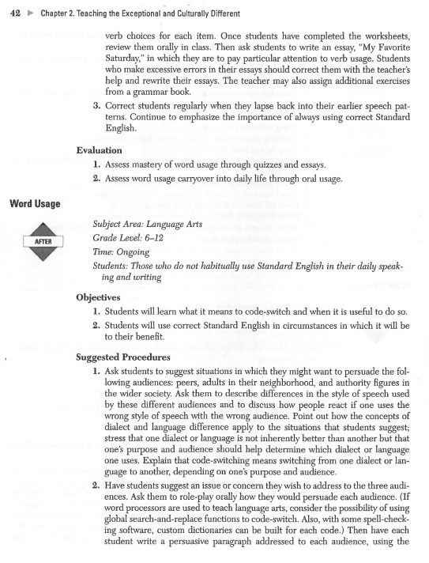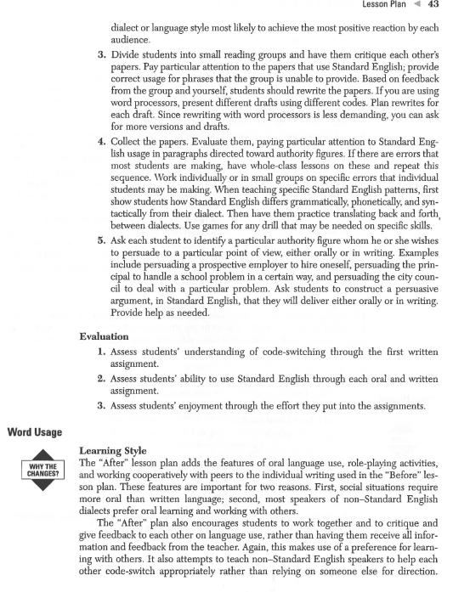 lesson Plan 119

Factoring Polynomials and Making Friends at the Same Time

Subject Area: Mathematics

Grade Level: 11-12
Time: One or two class periods

Objectives
1. Students will factor polynomials completely and accurately.
2. Students will enjoy abstract math problems.
3. Students will get along with their peers of different races and of the opposite sex.

Suggested Procedures
1. Divide students into groups of about five members each. The groups should be as race- and gender-mixed as possible, and should also mix good algebra students with those who have more difficulty in this area. Have each group select a name.
2. Demonstrate on the board how to factor a polynomial. If students do not under­
stand, demonstrate additional examples until they do understand.
3. Write a polynomial on the board similar to those that were demonstrated. One group is to figure out how to factor it and to do so on the board. The other groups are to demonstrate whether it was done correctly and, if it wasn't, what the cor­ rect solution would be. Scoring is done as follows:
Two points are given when the group solves the problem correctly ( but the
points are not awarded until after the other groups have evaluated the solution).
One point is given to the evaluating groups when they correctly evaluate the
solution of the group doing the problem.
No points are given to any group for incorrect solutions or evaluations.
4. Proceed to another problem; rotate the group at the board but repeat the pro­ cedure in step 3. Encourage group members to work together to figure out a solution.
5. Once students have mastered problems similar to those demonstrated by the teacher and each group has had the same number of turns at the board, demon­ strate a more complex problem and repeat the procedures in steps 3 and 4.

Evaluation
1. Give students three to five polynomials to factor independently; they should score 100 percent if the concept has been mastered.
2. Observe student-student interactions during the game and during other class activities to assess their improvement in social relationships.

120 Chapter 3.Human Relations

Factoring Polynomials and Making Friends at the Same Time

Cooperative Learning
The "After" lesson plan uses the same problems used in the "Before" plan but presents them in a team-games cooperative lesson. If used frequently, three outcomes of this change can be expected: (1) students will make friends with teammates they might previously have ignored, (2) students will like math more, and (3) students will learn the concepts better. One of the authors used this procedure to teach grammar to high school students with learning disabilities. It worked so well that students not only learned the concepts and made new friends, but also requested that the author continue teaching them more grammar than the author bad planned because the process of learning it "turned them on"!

