Executive Function Skills and Its effect on Student Performance
SRBI Symposium, November 24, 2015
Learner Outcomes:

Notes:

- Increase understanding of 11 Executive Functioning Skills
- Share strategies to support development of executive function skills through positive behavior instruction

A Career Life Changing Perspective
IQ test scores, under optimal test conditions, account for 40% to 50% of current expected achievement.
Thus, 50% to 60% of student achievement is related to variables “beyond intelligence”.
Source: National Center on Educational Outcomes, Synthesis Report 55, 2003
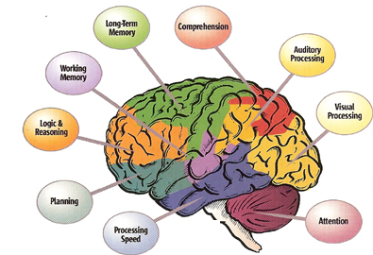

Executive Function Skills are:
- A set of intrinsic skills or mental processes used to navigate daily life
- Develop gradually and at different rates for different people
- Part of demands of schooling that are needed for academic and social success
- Observed behaviors of concern can be a result of gaps in Executive Function Skills
- With explicit teaching and practice able to change learned habits and use less effort

Types of Executive Function Skills
Skill Type | The ability to…
Impulse Control | Resist the urge to say or do something allowing time to evaluate situation
Working Memory | Hold information in mind and use it to complete a task
Emotional Control | Manage feelings in order to achieve goals, complete tasks, or control behavior
Sustained Attention | Maintain attention to a situation or task in spite of distractions, fatigue, or boredom
Task Initiation | Begin projects without undue procrastination, in an efficient or timely fashion
Planning/ Prioritizing | Create steps to reach a goal and make decisions about what to focus on
Organization | Create and maintain systems to keep track of information or materials
Time Management | Determine how much time have, how to allocate it, and how to stay within time limits
Flexibility | Adapt plans in face of obstacles, setbacks, new information, or mistakes
Goal-Directed Persistence | Have a goal, follow through to completion, and not be put off or distracted by competing interests
Self-Monitoring | Observe oneself in situation; monitor and evaluate how problem-solve

- What are the general EF skills needed to engage in the learning?

- What are the critical EF skills for completing the designed learning activity?

Resources:
- Dawson, P. & Guare, R. 2009. Smart but Scattered: The Revolutionary "Executive Skills" Approach to Helping Kids Reach Their Potential. The Guilford Press. NY, NY.
- Dawson, P. & Guare, R. 2010. Executive Skills in Children and Adolescents: A Practical guide to Assessment and Intervention, 2nd ed. The Guilford Press. NY, NY.
- Meltzer, L. 2010. Promoting Executive Function in the Classroom. The Guilford Press. NY, NY.
- Kuypers, L. M. 2001. The Zones of Regulation: A Curriculum Designed to Foster Self-Regulation and Emotional Control” Thinking Social Pub. Santa Clara, CA.

Contact Info:
Jessica Stonoha, Psychologist Stonoha.jessica@north-haven.k12.ct.us
Lauren Payne, Literacy Coach Payne.lauren@north-haven.k12.ct.us
Clintonville School, North Haven, CT

Kc Nelson-Oliveria, Consultant, SERC nelson-oliveria@ctserc.org
The SERC Library (www.ctserc.org/library) offers more than 10,000 resources for educators and families, including:
  - books;
  - instructional materials;
  - tests;
  - journals;
  - DVDs;
  - online databases and topical Lib Guides; and
  - children’s books.

