CAS Grant Application
Coaching support for Newly Appointed
special education administrators

Connecticut Association of Schools
Contact: Marie Salazar Glowski
E-Mail: mglowski@casciac.org
Due Date: 12/29/2017

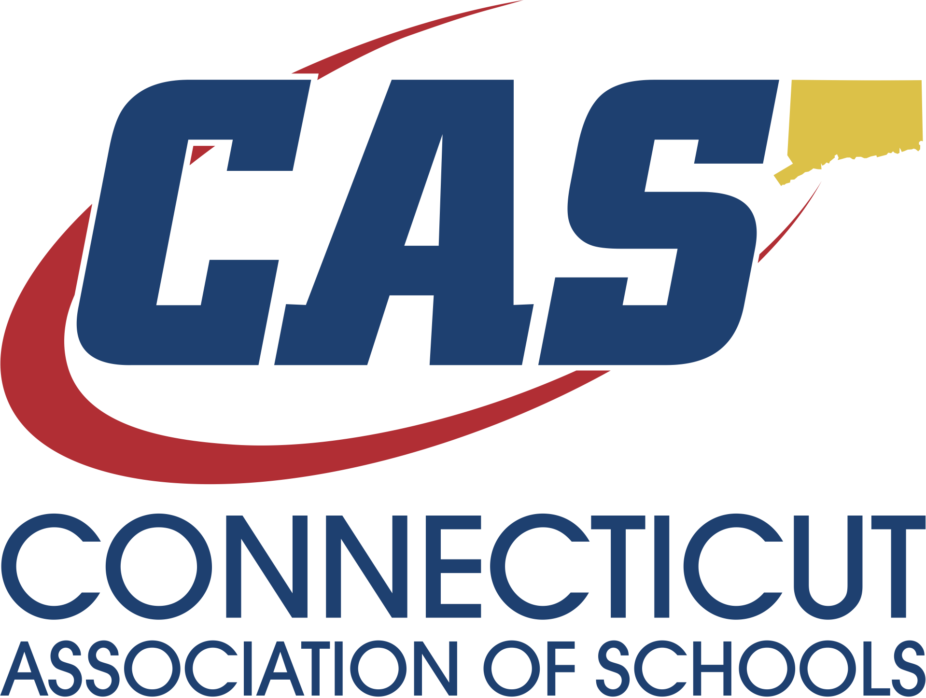

Affirmative Action Statement

The Connecticut Association of Schools is committed to a policy of equal opportunity/affirmative action for all qualified persons. The Department of Education does not discriminate in any employment practice, education program, or educational activity on the basis of race, color, religious creed, sex, age, national origin, ancestry, marital status, sexual orientation, gender, gender identity or expression, disability (including, but not limited to, intellectual disability, past or present history of mental disorder, physical disability or learning disability), genetic information, or any other basis prohibited by Connecticut state and/or federal nondiscrimination laws. The Department of Education does not unlawfully discriminate in employment and licensing against qualified persons with a prior criminal conviction.

AN EQUAL OPPORTUNITY/AFFIRMATIVE ACTION EMPLOYER

TABLE OF CONTENTS

BACKGROUND FOR DEVELOPMENT OF GRANT page 3
SCOPE OF SERVICES Page 4
GRANT APPLICATION REQUIREMENTS page 5
SELECTION CRITERIA page 5
INSTRUCTIONS pages 6-7
ASSURANCES page 8

BACKGROUND FOR DEVELOPMENT OF GRANT
The Connecticut State Department of Education (CSDE), Bureau of Special Education and the Connecticut Association of Schools (CAS) partnership

This special education executive coaching model has been developed as a result of many requests from the field indicating that special education administrators would benefit greatly from the support of an executive coach with special education expertise. It was determined the CSDE would support this model through an application process made available to districts. Grant awardees will receive a coach at no cost for the services provided.

The coaching support assists participants in better negotiating the day-to-day and long-term challenges faced by special education administrators in today’s public schools. Coaches, familiar with both federal and state special education regulations, act as a sounding board, advisor, and organizer of differentiated support, while assisting with the development or enhancement of critical administrative skills necessary to the participant’s position. With the theme of systemic collaboration with all staff within the district as a backdrop, the CAS Executive Coach will help create or support an existing improvement/action plan for the selected special education administrator*; lending years of experience and expertise to the process. As a result of participating in this coaching model, it is anticipated that the participant will enhance their job effectiveness, thus benefitting not only themselves, but also the students, parents, and all district stakeholders. Through an enhanced awareness of special education regulations, potential outcomes include decreased issues of noncompliance; improved programming for students with disabilities, increased parent satisfaction, improved staff and family communication, improved staff satisfaction and retention, and increased collaboration across all staff.

Through this grant, the CSDE and CAS will work collaboratively with partner districts to:
- Support a new or experienced special education administrator;
- Create and or support an existing, structured individualized support plan for the administrator;
- Build capacity for supporting equitable learning experiences for all students with disabilities; and
- Enhance district capacity for implementing and sustaining successful practices that are developed throughout the year by providing training and technical assistance and resources to identified special education administrators.
*Such plan is not intended to be a formal part of the administrator evaluation process.

SCOPE OF SERVICES

Services will be provided at no cost to the districts that are awarded the grant.

- CAS Executive Coach

- A coach with special education expertise will be assigned to the special education administrator. The coach will meet with the administrator for up to 10 days. during the grant period.
- The coach will become familiar with the district’s special education department and together with the administrator will develop a support plan.
- The coach will provide technical assistance and strategies to the special education teacher to implement the plan and achieve the goals within the plan.
- The coach will be available by email and phone.

- Project updates and end of the year summary.

- The coach will submit logs providing an overview of activities, questions and feedack and a self reflection of each session to include its outcomes and next steps.
- An end of the year summary will be provided to each administrator, which will document progress related to the structured individualized support plan inclusive of an action plan for next steps.

GRANT APPLICATION REQUIREMENTS
Applicants must address each of the questions in the instructions section of this application. The grant award will be considered for districts that address the following:

- The district has demonstrated the need for the assignment of a coach in a clear and concise manner.

- The project is likely to have a positive impact on students and has the potential to enhance the culture of the department.

- The district will support the administrator during the implementation of the grant project and will work to sustain positive results beyond the close of the grant process.

Grant Period
The grant period will begin January 2, 2018 and end on June 30, 2018.

Grant Award
The CSDE and CAS reserve the right to award this grant in a manner deemed to be in the best interest of the district and its students.

SELECTION CRITERIA
CAS and the CSDE will review all grant applications. A limited number of applicants will be awarded this grant. It is the intent of this program to support special education administrators across the educational regions of the state. The following information, in addition to the requirements, terms and conditions identified throughout this document, will be considered as part of the selection process.

Selection Criteria:
- Submission of grant application with responses to all questions posed.
- Other Information and Signatures as requested

INSTRUCTIONS TO GRANT APPLICANTS

Proposal Schedule
Release of Grant Application: | December 11, 2017
Proposal Due Date: | December 29, 2017

Please clearly describe your rationale for applying for this grant and the services provided within the responses to the following:

  - Organizational information - Include the title of the special education administrator, and the number of years in the position, please specify number of years in the current district and number of total years as a special education administrator.

  - Describe why the special education administrator would benefit from having a coach (Suggested areas of focus: Special Education Student Outcomes, Department Efficiencies, etc.).

  - Expected goals - List at least 2 goals that you hope will be achieved throughout the year as a result of the special education administrator working with a coach.

Grant Application Information
District:
__________________________________________________________________

Address:
___________________________________________________________________

Name of the Special Education Administrator applying for a coach:
__________________________________________________________________

Telephone #’s: ___________________________________________________________________

Email Address: ___________________________________________________________________

Questions
Questions may be submitted in writing to: Marie Salazar Glowski, Connecticut Association of Schools - mglowski@casciac.org.

Proposal Submission
All responses to this solicitation must be submitted as follows:
Proposal must include 2 complete copies and must be received, by December 29, 2017 at:

The Connecticut Association of Schools
c/o Marie Salazar Glowski, Director of Executive Coaching
30 Realty Drive
Cheshire, CT 06410

APPENDICIES

Appendix A
Statement of Assurances
PROJECT: The Connecticut Association of Schools Special Education Executive Coaching Grant:
THE APPLICANT, ____________________________________, HEREBY ASSURES THAT: (Insert Name)

1. The applicant has the necessary legal authority to submit a grant application.

2. The filing of this grant application has been duly authorized to file this application for and on behalf of said applicant.
3. The activities and services for which assistance will be provided under this grant will be under the control of the applicant.

4. The project will be operated in compliance with all applicable state and federal laws and in compliance with the regulations and other policies and administrative directives of the CAS and the CSDE.

5. The coach will provide an end-of-year summary (within 30 days of the project completion), as specified by CAS. Overall satisfaction with the services provided will be included.

6. CAS reserves the exclusive right to use and grant the right to use and/or publish any part or parts of any summary and materials resulting from this project.

7. The applicant will protect and save harmless the CAS and the CSDE from financial loss and expense, including fees and legal fees and costs, if any, arising out of any breach of the duties, in whole or in part, described in the application and in the contract, if awarded;

I, the undersigned authorized official, hereby certify that these assurances shall be fully implemented.

Signature _____________________________________________________________

Name (typed)__________________________________________________________

Title (typed) ___________________________________________________________

Name of District ___________________________________Date ________________

