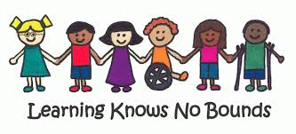

Loanable Assistive Technology (AT) Resources Collection and Demonstration Site Now Available at the SERC Library

Come visit and explore the Library’s newest collection of devices and equipment that can support the needs of children, youth and adults with disabilities to be more independent in their daily routines and activities. Currently, over 75 low-tech to mid-tech resources are represented in the collection. The collection also includes a small number of high-tech iPads and Chromebooks, which can be borrowed to try out various AT Apps in areas such as literacy and math skills development as well as early childhood education.

This new collection is supported by a new service at the Library. Receive an informal preview of assistive technology resources available for loan from Library staff or schedule a formal demonstration of AT devices within the collection with Dr. Smita Worah, SERC Consultant for Technology in Education. Both options offer visitors an opportunity to ask questions and gain information about the potential usefulness of a device for either themselves or someone with whom they live and/or work who has a disability.

For questions regarding borrowing resources from the AT collection, interested individuals may email the Library at circ@ctserc.org or call 860-632-1485 and press option 4. Please refer to the Library Webpage at www.ctserc/library for the schedule of Library hours. To sign-up for a demonstration, please contact Linda Adorno, Project Specialist for the SERC Technology in Education Initiative at adorno@ctserc.org and 860-632-1485, ext. 241.

The SERC Library has proudly served the needs and interests of families, educators, university students and community providers for more than 45 years. Its current and specialized collections of resources and materials are aligned in support of improving the quality of learning and life outcomes for children and youth of all abilities. The AT resources collection is made available through a partnership with the Connecticut State Department of Education, Bureau of Special Education, the Connecticut Department of Rehabilitative Services and the Connecticut Tech Act Project.
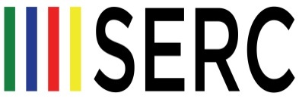
LIBRARY
100 Roscommon Drive · Middletown, CT 06457 · 860-632-1485, option 4 · www.ctserc.org/library

