SERC Library Policy on iPads & Chromebooks Borrowed from the Assistive Technology (AT-3) Collection

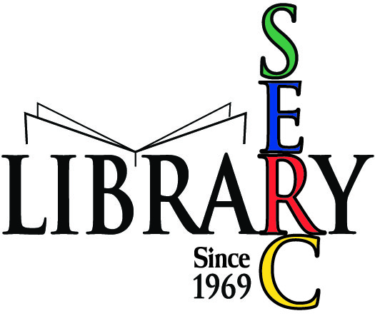

The SERC Library is pleased to announce through a pilot project with the Technology in Education (TIE) Initiative the availability for loan of five (5) iPads and five (5) Chromebooks (equipped with charger power supply cord) for the purpose of providing children/youth with special needs and their families/caregivers an opportunity to try out various AT Apps in their everyday environment. Each electronic device has preloaded a set of educational AT Apps with a specific focus, for example, communication skills and supporting the needs of preschool-aged children. (Please see the Library catalog record for descriptive information specific to the Apps contained on each device.)
Policy
- A patron must have a current library membership and be in good standing with no pending overdue materials or fines to be able to borrow technology available through this collection.
- A patron must sign a “Loanable Technology Borrower’s Agreement” once per year; the agreement will remain in a secure file for a period of one year.
- A current library membership card and a valid driver’s license must be presented to be able to borrow an item from this collection (AT-3).
- Only one item from the collection can be borrowed at a time. An iPad and a Chromebook cannot be borrowed at the same time.
- The loan period for borrowing an iPad or Chromebook is two (2) weeks with a one-time, one (1) week renewal period, provided a hold has not been placed on the resource by another patron.
- An electronic device becomes the responsibility of the patron once it has been placed on loan through “check-out” procedures at the circulation desk. Borrowed technology must not be left unsecured at any time.
- Use of loanable technology is restricted solely to trying out the assistive technology Apps that are preloaded on each device. When borrowing a Chromebook, use is made possible only through the installed Google account.
- Use of loanable technology requires Wi-Fi Internet access once outside the public Wi-Fi area of the Library. A charger power supply cord will be loaned with each device. Currently, peripheral equipment (e.g., mouse, DVD drive) is not issued.
- An overdue fine of $3.00 per day will apply toward the late return of an electronic device. Accumulating fines will suspend after ten (10) days and the unreturned resource will be marked as missing in the borrowing patron’s account. The device will then be remotely disabled and an invoice will be sent for the full replacement cost plus a $25.00 processing fee.
- All loanable technology devices will be inspected for damage upon their return. If damage has occurred, repair or replacement cost will be determined with an invoice sent to the borrowing patron inclusive of a $25.00 processing fee.
- All loanable devices must be returned to the circulation desk at a time when the Library is open. Electronic devices cannot be returned by mail, through Inter-Library Loan or left in the lobby or elsewhere within the building.

iPad & Chromebook
BORROWER’S AGREEMENT

This borrowing agreement is effective for a one year period from the date of signature.
- I understand that I am responsible for proper handling and use of borrowed assistive technology (AT) resources.

- I understand that it is illegal to copy or distribute any AT software borrowed through the Library.

- I understand that I am responsible for the timely return of borrowed AT resources.

- I understand that it is necessary to complete a brief survey about the loan experience when returning borrowed AT resources to the Library.

- I understand that in the event of loss or damage of borrowed AT resources that I must immediately contact the Library at 860-632-1485, option 4.

- I understand and will hold harmless SERC, its Library and staff from any losses, damages, expenses, claims, demands, suits and/or actions by any party in connection with AT resources borrowed through the Library.
By signing below, I understand and agree to the above policy pertaining to the use of loanable technology from the Assistive Technology (AT-3) Collection at the SERC Library.
Name of Borrower:_____________________________________________________________________
Signature of Borrower:__________________________________________________________________
Email Address of Borrower:______________________________________________________________
Library Membership Number:_____________________________________
Date:____________________
_____________________________________________________________________________________
For Staff Use Only
Procedure:
- Have patron sign agreement form.
- Add note to patron’s account that form has been signed and date signed.
- File agreement form.
- Staff Initials:_________________

